QUICK RECAP
In the previous week, we learned about the foundations of Boosting algorithms. Let us quickly recap what we have covered so far.
- Introduction to Boosting
- Introduction to Boosting Algorithms
  - Adaboost
  - Gradient Boosting
  - XGBoost
- Introduction to Stacking

COURSE OVERVIEW
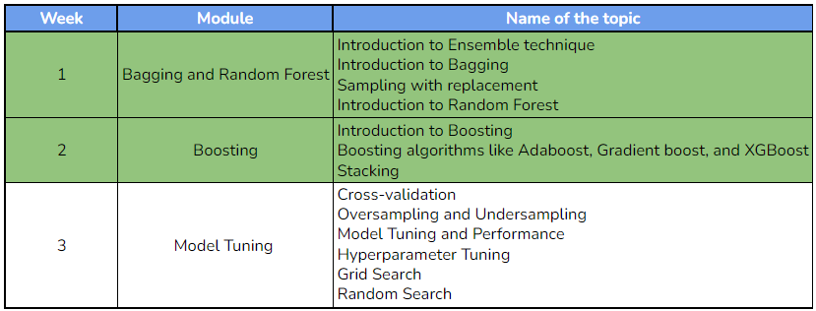

WEEK 3 OVERVIEW
This week, we will explore cross-validation and its significance, how to handle class imbalance using oversampling and undersampling techniques and understand the process of hyperparameter tuning. Additionally, we will be introduced to model tuning and performance evaluation using GridsearchCV and RandomsearchCV. The following topics will be covered in this module:
- Understand the importance of cross-validation and perform k-fold cross-validation
- Address class imbalance with oversampling and undersampling
- Tune a model's hyperparameters to improve its performance
- Introduction to model tuning and performance
- Use GridsearchCV and RandomsearchCV to tune models

LEARNING INSTRUMENTS
Week | Module | No. of videos | Total duration | No. of Test Your Understanding Quizzes | No. of Weekly Graded Quizzes
3 | Model Tuning | 9 | ~2.25 hour | 9 | 1

